**Q. Create a Control Flow Diagram, Repository Model, Client-Server Model and Layered Model of a system of your choice.**

**Trouble Ticketing System**

Control Flow Diagram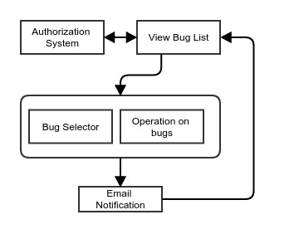

Member Repository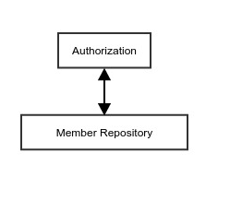

File Repository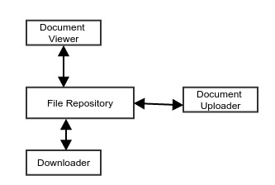

Client-Server Model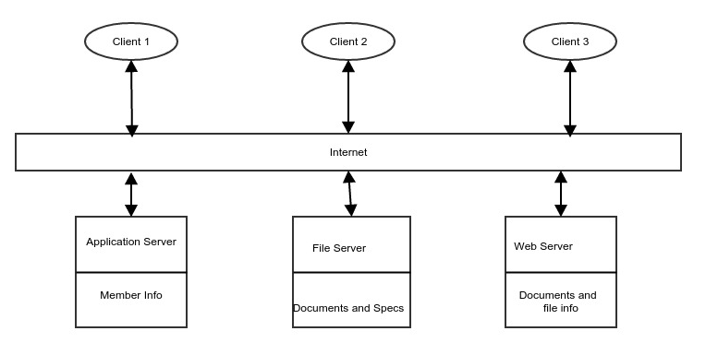

Layered Model